Light Emitting Diode Concepts
In a light emitting diode (LED) we operate the device in forward bias. The effect is to inject electrons and holes into the active region where they can recombine. When the electrons fall from Conduction Band to Valence Band (electron recombining with hole) energy is lost which is equivalent to the difference in energy between the bottom of the conduction band and the top of the valence band (or the semiconductor bandgap).
The energy can be lost in many ways:
- Emission of a photon with energy equal to the bandgap ☺
- Emission of phonons through some defect ☹
- Emission of a lower energy photon and phonons through some defect state ☹
These can be shown schematically below

Transitions of type 1 above are called Radiative Transitions: they produce light at the wavelength we want.
The other transitions are Non-radiative: There is electrical energy put in to the device but there is no useful light energy out.
Note that normally we are only interested in light emitted at the bandgap energy, longer wavelength light is normally wasted energy. It is possible that such long wavelength emission can actually be detrimental in the application.
For example in spectroscopy we excite at one wavelength and detect at another. If the signal to be detected is weak then scattered light from the LED might swamp the signal to be measured. A second example is that if a blue LED has a defect which gives some yellow light then the apparent LED colour will change to the eye, taking on a whitish tinge
Energy lost to lattice vibrations is not just energy lost. The vibrations are in essence heat warming the semiconductor device up. Heat tends to lead to more and more non-radiative transitions making the device performance worse.

LED efficiency
As, usually, we want as much light out from the LED as possible, for all LEDs their efficiency is a vital parameter. We can define efficiency in three different ways:
Internal Efficiency
This is defined as the fraction of electrons injected that lead to the production of a photon in the active region of the device.
External Efficiency
This is defined as the fraction of electrons injected that lead to the production of a photon that is actually emitted from device.
Wall Plug Efficiency
This is simply the ratio of the optical power produced by the device compared to the electrical power injected into it.

What is the difference between Wall Plug and External Efficiency?
Both External Efficiency and Wall Plug efficiency are measures of the input of current into the device versus the output of light. The difference is that in the case of the wall plug efficiency we consider the voltage drop across the device and the energy of the photons produced.
If the voltage drop in volts has the same value as the energy of the photons produced in electron volts then the two values would be equivalent.
However, we want as much light out of the device as we can. The more light we can get out of the device per unit area of semiconductor used the better, as the cost in making the devices is certainly not negligible. This means that series resistance will be significant at the operating point.
Designing the device to ensure the series resistance is as small as is practicable is important, as this both improves the wall plug efficiency, but more importantly resistive losses are heat into the device, leading to higher temperatures at that operating point, which tend to inherently reduce the device efficiency, as discussed briefly above.

Internal Efficiency
The internal efficiency can be broken down into two parts:
The Injection Efficiency: a measure of what fraction of electrons recombine region of the device we wish them to do so.
The (real) Internal Quantum Efficiency: a measure of what fraction of the electrons recombining in the active region do so radiatively.
Let us consider a simple p-n junction diode at first. This is a so-called homojunction LED. In many cases we wish the recombination to occur on one side of the junction, and we can do this by making one side of the device more heavily doped than the other: Making the device p⁺-n will lead to hole current dominating (holes injected into n-type side and recombining there) and hence a high injection efficiency if this is what we are designing for.
The internal quantum efficiency can be considered knowing the radiative and non-radiative recombination rates. (The radiative recombination rate is the number of electrons recombining with holes and emitting a photon per unit second)
We can hence get: 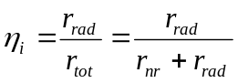
Where 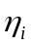 is the internal quantum efficiency, 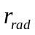 the radiative recombination rate, 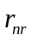 the non-radiative recombination rate and 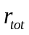 the total recombination rate. The reciprocal of the recombination rate is the recombination lifetime, given by . Thus we can also write the above equation as:
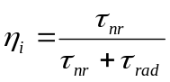
In a direct gap material 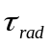 is short, normally much shorter than the non-radiative lifetime meaning that is high. However, for an indirect gap material, such as Si then the separation of the conduction band minimum and valance band maximum in reciprocal space means that the radiative life time is long, normally much longer than the lifetime for a non-radiative transition meaning little or no light is produced: is low.
It should be noted that the probability of carriers recombining non-radiatively tends to increase with temperature, so the internal quantum efficiency degrades as the device runs hotter.

External Efficiency
It is not sufficient just to produce photons. In order for us to see them they must first escape from the device. However there are many reasons why a photon may not be able to do so:
1.
2.
3.
4.
5.
We can show these effects schematically for an LED chip

The external efficiency of the LED produce of the internal efficiency, discussed above times the extraction efficiency which is a measure of what fraction of the photons produced in the device can actually escape from the material and be observed.
So how can we maximise the light output?
In a homojunction LED, for the layer absorption we can make the contact metal area small and the semiconductor material above the active region as thin as possible, but there is little we can do about the substrate. Before looking at practical ways that we can address those design issues let us consider the reflections in the device:
These are the effects of the refractive index difference between the semiconductor material and air, which leads to the Fresnel reflection and the Critical Angle effect we mentioned above.
At the interface between two materials the reflection will be given by the equation:
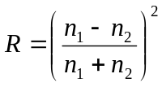which between a semiconductor and air becomes: 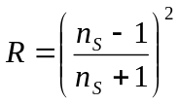
Thus the light transmitted can be shown to be: 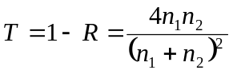; or 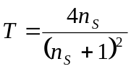
Let us now consider the effect of critical angle.
Snell’s Law states that 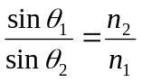
Where the angle that between the normal to the interface between the two materials and that of the ray of light in each case. This is shown in the figure opposite.
Total internal reflection will occur when the angle of ray of light in the second material reaches 90º.
At this point the light cannot escape from the material and all of it will be reflected back. For our semiconductor material we can rewrite Snell’s law at the Critical angle, 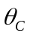 as:
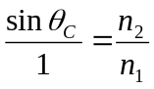 and hence for our semiconductor: 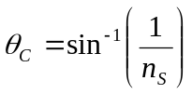
To simplify our calculation let us make the assumption that light beams produced from the active region with an angle to the material surface less than the critical angle will have a fraction of its intensity emitted into the air, given by the equation for Fresnel reflection. If the beam has an angle greater than the critical angle then the light will be subjected to total internal reflection in the device and be lost.
Now the emission of photons in an LED is a spontaneous process and is in all directions. Therefore what we are required to know is what fraction of the photons have an angle less than the critical angle.
To do this we need to consider the solid angle. The simplest way to consider the concept is to first consider that an angle, measured in radians is basically a measure of what fraction of the circumference of a circle we have. (Hence an angle of 360º equates to 2π radians.) Similarly a solid angle is a measure of what fraction of the surface area of a sphere we have. (The solid angle for photons produced internally by the active region LED will therefore be 4π steradians as they will travel in all directions).
The area we have will be a circle superimposed on surface of this imaginary sphere where the angle between the centre of the circle and the any point on the circumference, taken from the centre of the sphere will be . This is shown in the figure opposite.
The solid angle can be calculated from:
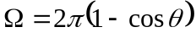
The fraction of photons emitted will be therefore given by: 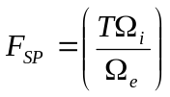
Substituting gives 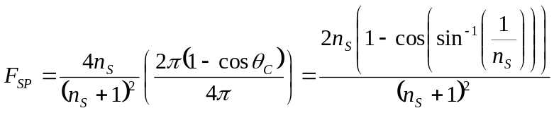
Using the above we can estimate what fraction of the photons that we have produced we can actually get out of the device if we know the refractive index of the semiconductor.
Unfortunately for LEDs, the refractive index of a semiconductor is fairly high.
For GaAs and similar materials, used to make orange, red, and infrared emitters the refractive index is around 3.5
For GaN and related materials, used to make ultra-violet, blue and green emitters the refractive index is closer to 2.5
Substituting these values into the equation (HOMEWORK) will show that the expected fraction of photons that are emitted, which is a first estimate of the extraction efficiency of the LED will be a few percent at best. This is clearly not acceptable for many applications. Next time we will look at methods to improve LED performance to obtain efficiencies of many 10s of percent.

